Hello and welcome families!
You might like to
pop me on your noticeboard

All children are welcome at St Matts.
Kids are an important part of our church community.

We have a crèche for infants in the crèche room (located under the hall) from 10am.
All children from three up begin in church with their family and friends and leave
during the break to join their groups, around the coloured flags.
The primary kids enjoy Big Group Time before separating into smaller groups.

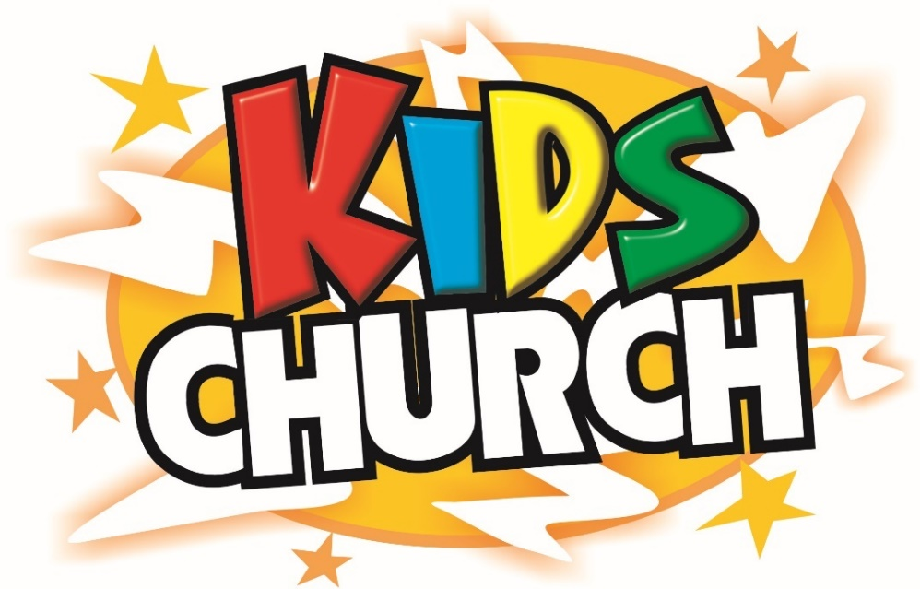

Term 3, 2019

In Term 3, the preschool kids will be following a program called ‘God’s Amazing Promises’ which will teach the children that God made amazing promises to lots of different people throughout the bible & those promises came true. Like those people, we can also believe every promise God makes.

The primary-aged groups are learning from Matthew’s Gospel, chapters 1-7, which include the stories of Jesus birth, baptism, early ministry and parables.

We’ll also be singing, learning memory verses and having lots of fun together.

We would love you to pray for us and ask what we’ve been learning throughout the term!

Kind regards, Christine Semple
Children’s and women’s worker
St Matt’s Ashbury

Kids Church Groups 2019

Yellow Preschool | Blue  Kindy | Blue  Yr1 | Green  Y2-3 | Orange  Y4 | Red  Y5-6
Abi  Alessandra  Annie  Bethany S  Cameron  Davey  Evie  George  Juliet  Phoebe | Joshua  Lewis  Lydia  Paige  Rachael  Rosie  Susie | Alana  Amelia  Bethany C  Eli  Huck  Jojo  Lucy  Maxy  Oscar | Aaron  April  Charlie H  Eden  Eliza  Emma S  Josiah  Marcus  Sophie  Tadhg | Asher  Cadell  Chloe  Jude  Oliver B  Rebecca  Robbie | Caleb  Charlie M  Ed  Izzy  James  Jasmine  Joseph Y  Lily  Mariella  Oliver C  Poppy  Wesley

Yellow Preschool God’s Amazing Promises
Preschool kids need to be signed in and out by a parent or carer.

Date | Story | Bible
28th July | Abraham | Genesis 12, 15
4th August | Isaac | Genesis 12-21
11th August | Joseph | Genesis 37-46
18th August | Exodus | Exodus 1-20
25th August | Joshua | Joshua 1-6
1st September | David | 1 Samuel 16-17
8th September | Solomon | 1 Kings 11:1-13
15th September | The Exile | 2 Kings 24:8-16
22nd September | Jesus | John 2, 4, 5, 6, 9, 11, 20:31

K-6: Matthew 1-7

Date | Focus | Bible
28th July | God Saves | Matthew 1
4th August | God’s Plan Can’t Be Stopped | Matthew 2
11th August | John the Baptist & Jesus’ Baptism | Matthew 3
18th August | Jesus’ Temptation | Matthew 4
25th August | Be Salty | Matthew 5:1-16
1st September | Murderous Anger | Matthew 5:21-26
8th September | Promises, Promises, Promises | Matthew 5:33-48
15th September | For God Alone | Matthew 6:1-18
22nd September | The Wise & Foolish Builders | Matthew 7:24-27

Leaders & Locations

Group | Leader | Location
Yellow Preschool | Coralie Bywater | Second crèche room  (Next to the toilets)
Blue K1 | Christine Semple | Front half of the hall
Green Y2-3 | Mike Jones | Back room of the hall
Orange Y4 | Stephen Mugridge | Back half of the hall
Red Y5-6 | Anita Hawkins | Small room under church

Memory verses K-6

The Lord’s Prayer
⁹ “Our Father in heaven,
hallowed be your name,
¹⁰ your kingdom come,
your will be done,
on earth as it is in heaven.
¹¹ Give us today our daily bread.
¹² And forgive us our debts,
as we also have forgiven our debtors.
¹³ And lead us not into temptation,
but deliver us from the evil one.”
Matthew 6:9-13

Song K-4

‘Jesus Saves! Jesus Saves!’ – Colin Buchanan (‘Christ the King of Christmas’ album)

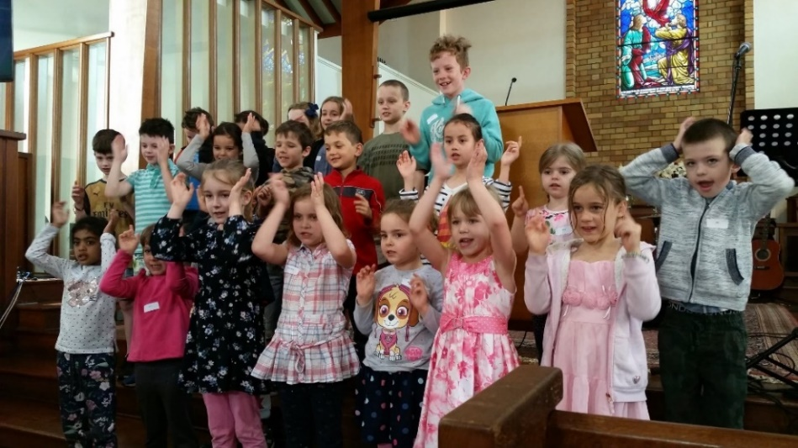

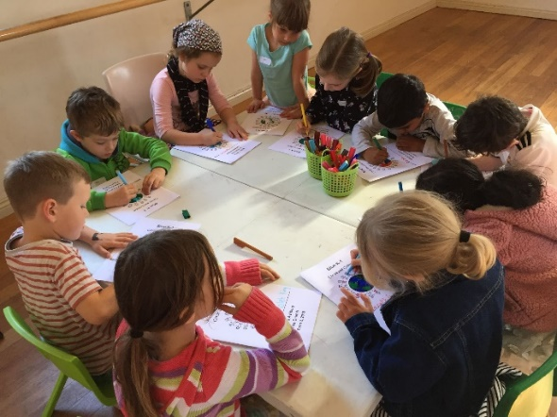
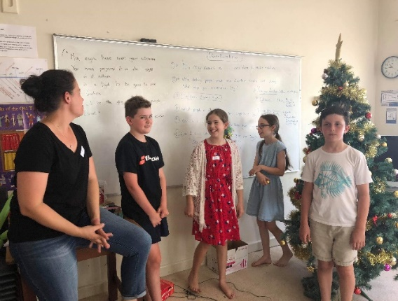

All our leaders have Working with Children Checks and Safe Ministry Training.

